April 7, 2015

To the Council on Academic Affairs:

I am writing to request that the proposed changes to History of Art 2003 (The Art and Visual Culture of East Asia) and 2003 Honors be considered by the committee in time for their implementation Autumn semester 2015. I realize that we are submitting (some of) these changes well past the recommended deadline, and for that I apologize. Our department is at a historic low in terms of personnel (both faculty and staff)—indeed, that’s part of the reason we’re requesting the particular changes we are—and this year has been an unusually busy one, especially for those who are or will be teaching the two courses in question.

We had originally hoped to offer HA2003 Honors for the first time this semester, but—even though it received approval (minus the Historical Studies designation) in November—we could not advertise the course well enough to garner sufficient enrollments and so had to cancel it. At that point, we decided to offer it instead this fall—without quite realizing either that its GE status was dependent on the course change request we are now making for HA2003 or that course changes require a much longer lead-time than do new course approvals. (Even though I served a year on CAA and was a member of the College Curriculum Committee back when it was the CCI, this still seems wholly counterintuitive to me.)

Both courses are currently on the books in some form (although their content does not match), and both will be offered (in some form) in the fall. If, however, the proposals could be fast-tracked, and so approved by CAA before the end of the current semester, it would make for both stronger, more coherent courses and less confusion among the students taking them.

Again, I apologize for the delay and deeply appreciate your consideration.

Sincerely,
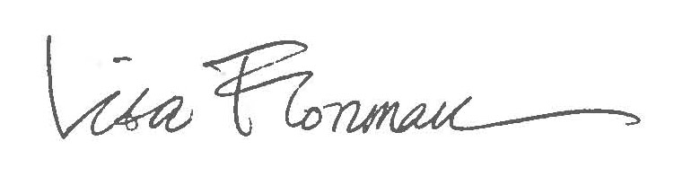
Lisa Florman
Professor and Chair
History of Art
Email: florman.4@osu.edu

